SIMPLIFYING EXPRESSIONS
Q1. Simplifying the following expressions by collecting the like terms.
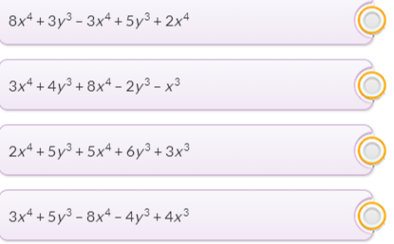

Q2. Expand and simplify the following.
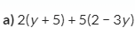

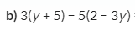
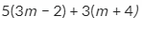
c)
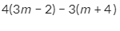
d)

Q3. Problem Solving: The length of the rectangle is four times it’s width. Take the width
as ‘x’ cm.
Form and simplify the expression for:
- Area of the rectangle

- Perimeter of the rectangle.

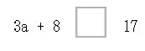
Q4. Put the correct sign (= or ≡) into the boxes

