Dubai Scholars Private School
Year 7 – Support Worksheet
Subject -Mathematics
Topic : Number Skills
1. a Add 40 and 60
b Work out the difference between 40 and 60
2.. Complete this sum.
37
+ 85

3 Work out
a 45 + 72
b 232 + 159

4 Work out
a 36 − 21
b 64 − 38
5 Kim has 37p. She sees a drink she wants for 60p.
How much more money does Kim need?
6 Work out
a 40 × 3
b 16 × 2
7. Work out
a 5400 ÷ 10
b 2300 ÷ 100

8 Hannah has 42p. Kyle has double what Hannah has.
How much money does Kyle have?

9 Which of these numbers is
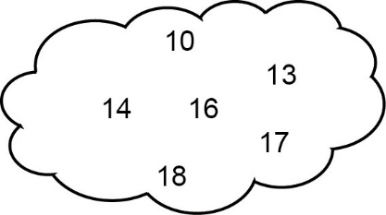
a a multiple of 5
b a multiple of 3
c a square number?

10 There are 4 wheels on each van in a street.
There are 5 vans in the street. How many wheels is this altogether?

11 At midnight, the temperature was −5°C.
By morning the temperature had risen by 3°C.
a Work out the temperature in the morning.
At noon the temperature was 4°C.
b Work out how many degrees the temperature had risen from
midnight to noon.
12 In a tube of sweets there are 2 pink sweets for every blue sweet.
There are no sweets of any other colour in the tube.
There are 12 blue sweets in the tube.
How many sweets are there in the tube altogether?

13 Work out
a 5²
b the square of 10
14 Put these temperatures in order, lowest first.
4°C −5°C −3°C 2°C 0°C

