Dubai Scholars Private School
Year 7 – Support Worksheet
Subject -Mathematics
Topic :Analysing and Displaying Data
- Here is a list of the trees in a wood.
Oak Ash Elm Beech Oak
Ash Ash Beech Ash Oak
Ash Elm Elm Beech Beech
Ash Ash Oak Beech Beech
- Complete the tally chart for these trees.
Type of tree | Tally | Frequency
b. Which tree is most common?
c. How many more beech trees are there than elm trees?
- Here is some information about the number of times some children were absent from classes.
Number of times absent | Number of children
Less than 3 | 08
3 | 13
4 | 32
5 | 12
a How many children were absent 3 times?
No child was absent more than 5 times.
b Work out the total number of children.

- Here are some numbers written in order.
4 6 7 10 10
a Write the median.
b Find the range.
- The pictogram gives information about the number of parcels sent from an office in each of the first 3 weeks in May.
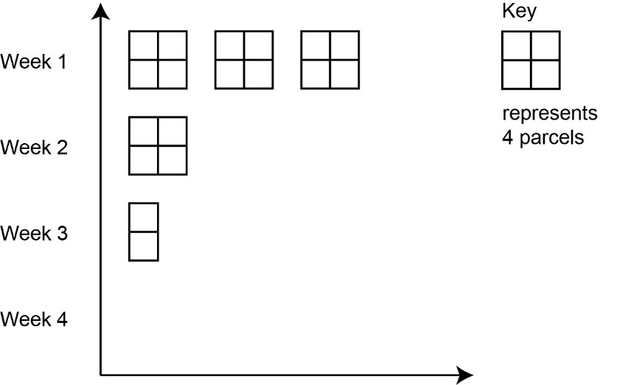
a Find the number of parcels sent from the office in Week 1.
Six parcels were sent from the office in Week 4.
b Show this information on the pictogram.
c Work out the total number of parcels sent from the office in all 4 weeks.

- Here are the numbers of goals that Stacey scored in her last 6 netball games.
3 0 8 7 6 6
a Work out the range.
b Work out the median.
c Calculate the mean.

- The bar chart shows the numbers and ages of children in a chess club.
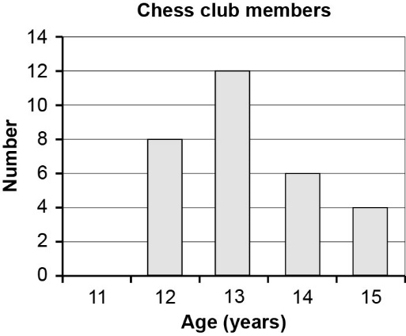

a Write the mode.
b How many children are in the chess club?

