Dubai Scholars Private School
Year 7 – Extension Worksheet
Subject -Mathematics
Topic :Analysing and Displaying Data
- Here is a list of the numbers of children living in the first 5 houses in a street.
4 2 6 1 2
a Work out the mean.
There are no children living in the sixth house in the street.
b Will the mean for all 6 houses be greater or less than for the first 5 houses?
Give a reason for your answer.
……………………………………………………………………………………………………………….
- Here is a list of the numbers of bags some shoppers were carrying when leaving a supermarket.
1 2 5 4 0 5 4
a Find the median.
b Work out the mean.
c Work out the range.
3 The diagram gives information about the number of drinks some people had one morning.
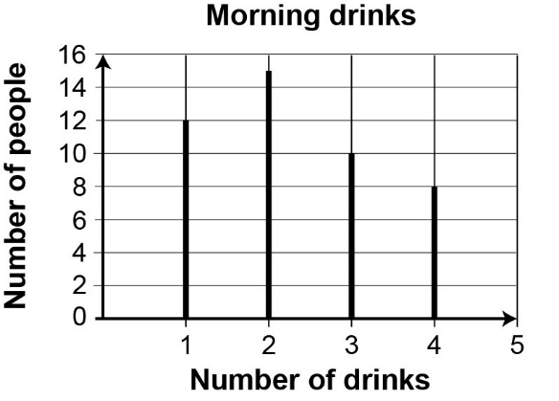
a Write the mode.
b Work out the range.

4. Here are the lengths of some lines that Bhavna measured with a ruler.
4 cm 7 cm 11 cm 7 cm 1 cm
a Work out the mean.
b Work out the range.
In fact, Bhavna measured from the wrong place on her ruler and the true lengths of the lines were all 1 cm more than she measured.
c Find the true mean length of these lines.
d Find the true range of the length of these lines.
5 The compound bar chart shows the number of calls Julie made and the number she received in
5 days.
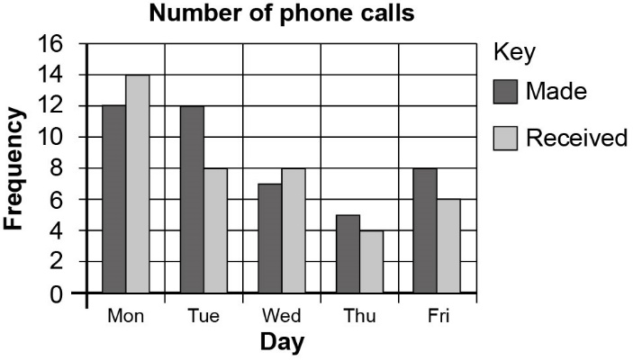
a On which day was the difference greatest between the number of calls made and the number received?
6. Here are the ages in years of some people in a sports club.
8 12 25 18 30 23 35 33 28 18
9 18 22 10 21 15 29 31 20 23
Complete this grouped frequency table using intervals of equal width.
The first interval has been done for you.
Age (years) | Tally | Frequency
0–9

