Q1. Simplify
a) 4k 2 + k (3 − k)
b) 4(x + 2y) + 3(y − x)

Q2. Answer the following questions.
The diagram shows a rectangle with length (3d + 2) cm and width
(d + 5) cm
a Write an expression for the perimeter of the rectangle.
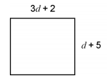
b Given that the perimeter is 30 cm, make and solve an equation to find d.

Q3. Find the value of each expression when a = 5 and b = −11
a) 5 + 2a²
b) (4a) 2b

