Self-Assessment: Rounding to significant figures.

Q1. Round each numbers accordingly.

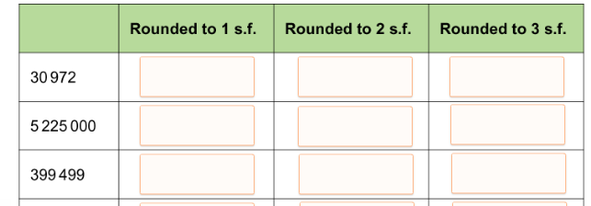

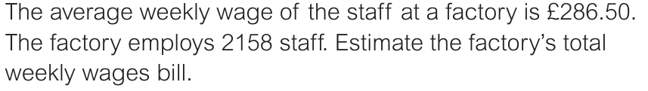
Q2.

(Hint: Round to 1 significant figure)

Q3. Estimate the following calculations by rounding each number to 1 significant figure.
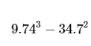

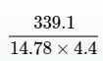

- 42 x 579

- 8241 ÷ 19

